Group: bioluminescence

Members: Justin Cabral, Jonathan Duran, Humberto Martinez, Miles Gregg

Credentials:

* Corporate:
  + Username: corporate
  + Password: password
* Managers
  + 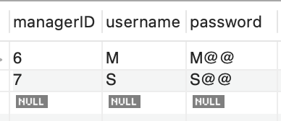

## GUI landing page:

* <http://cs509-group-project.s3-website-us-east-1.amazonaws.com/>